**E-SPORTS**

-By

Akshay Choudhary

NUID:001630590

**INTRODUCTION**

The E-Sports Group commenced trading as a single store in Boston, Massachusetts founded by Akshay Choudhary in 1993. We have now expanded to become not only the USA’s leading online sports retailer by revenue and operating profit, but also the owner of a significant number of world famous sport, fashion and lifestyle brands.

E-Sports offering an incredible choice of football boots, running shoes, football kits, fitness clothing and much more to improve your shopping experience. The site gives you access to a huge range of quality sports apparel being sold by our retail partners, which you can arrange to have delivered to your door from our extensive online catalogue.

Whether you are a beginner or a professional, our diverse product range will assist you to train and improve in your chosen sport or activity. Made by world famous external brands such as Nike, Adidas and Puma, as well as internal brands such as Dunlop, Slazenger, Everlast, Lonsdale and Karrimor, the quality of our products is exceptional. Our specialist sports apparel and fashion based retailing ensure that we stock everything that you need, whether you want to master a sport or just remain on trend.

Customer service is at the forefront of our business, and is key in enabling us to retain our position as Consumers’ Champion. As we continue to offer excellent value on sports equipment, clothing and sportswear, we are always pleased to receive feedback from you.

**FEATURES**

1. **Google Sign In –**

Customer can sign in to the website using google sign in. Once logged in the customer can view his/her cart and the products added to the cart.

1. **Browse Product catalogue –**

Customer can view variety of products sold on the website. Customer can filter the browsing of the products based on different brands.

1. **Add products to cart**

Customers can add all the products to the cart which they want to purchase.

Customer can view/update the cart.

1. **Check-Out**

Customer has successfully completed the transaction.

**References**

<https://developers.google.com/identity/sign-in/web/devconsole-project>

<http://wojodesign.com/simplecartjs-paypal-e-commerce-in-minutes/>

**Screenshots**

1.Homepage

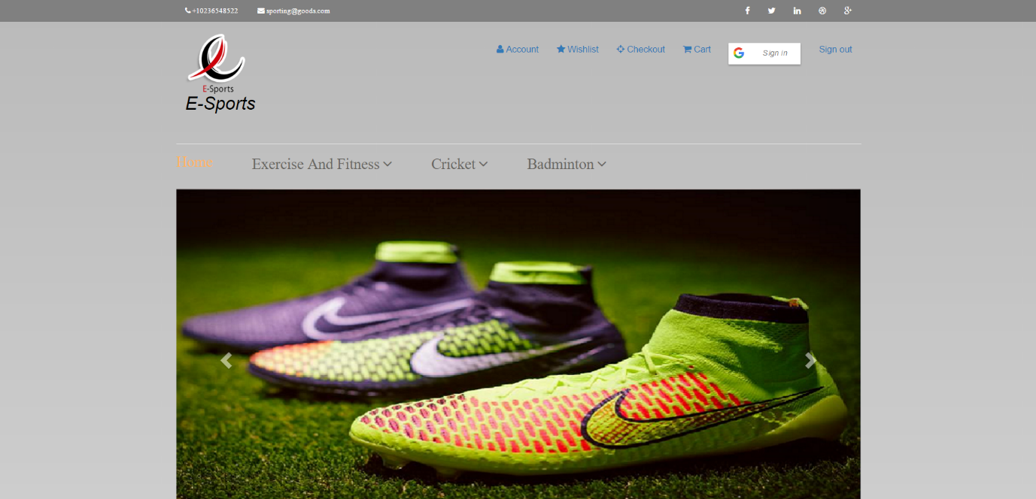

2.Products

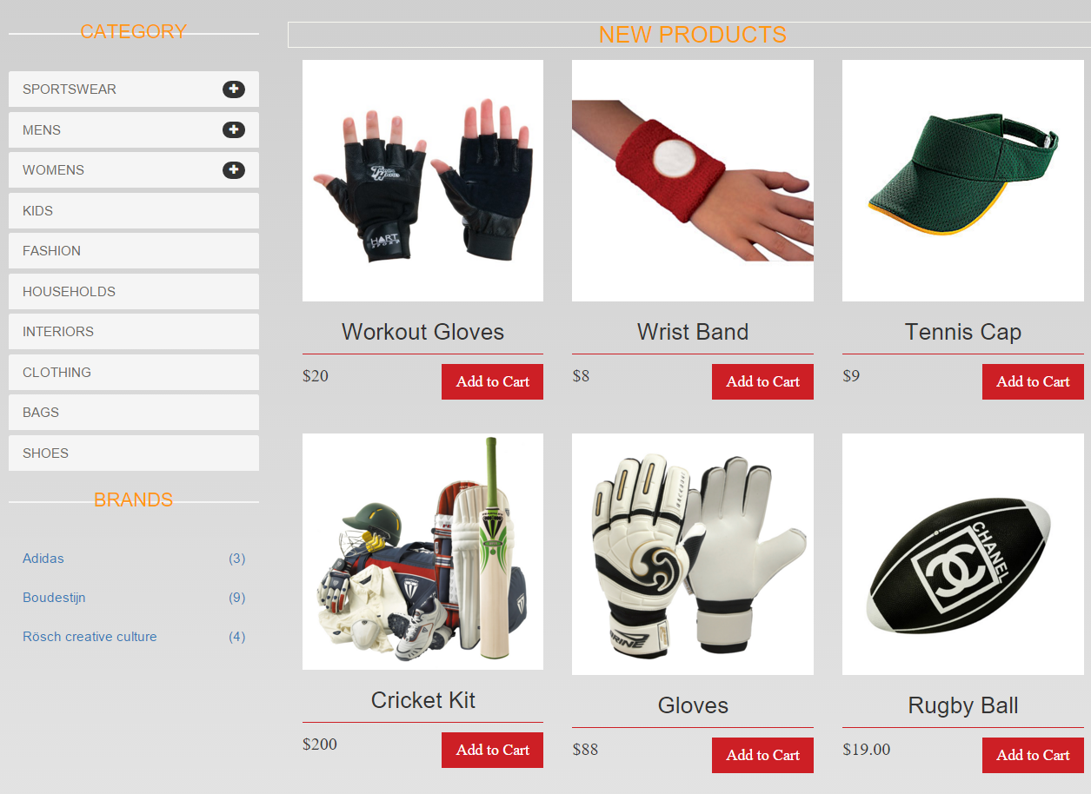

3.Footer

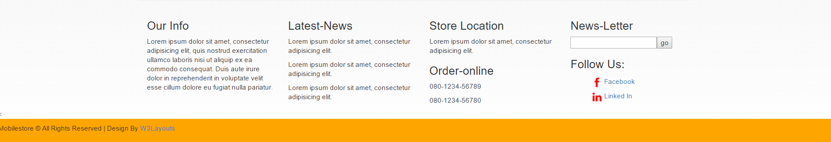

4.Sign In

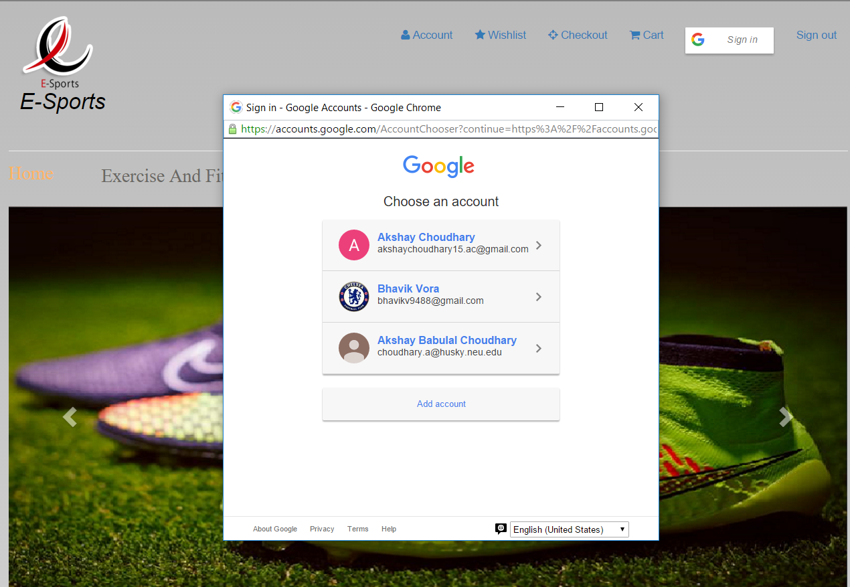

5.Signed In

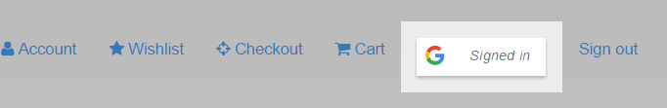

6.Add To Cart

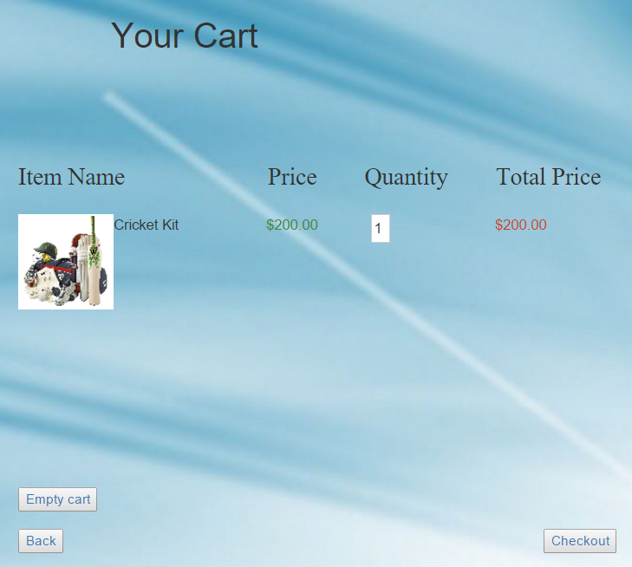

Source Code

Main File:

<!DOCTYPE html>

<html lang="en">

<head>

<meta charset="utf-8">

<meta name="viewport" content="width=device-width, initial-scale=1.0">

<link href="sportinggoods.css" rel="stylesheet">

<link rel="stylesheet" href="http://maxcdn.bootstrapcdn.com/bootstrap/3.3.5/css/bootstrap.min.css">

<script src="https://ajax.googleapis.com/ajax/libs/jquery/1.11.3/jquery.min.js"></script>

<script src="http://maxcdn.bootstrapcdn.com/bootstrap/3.3.5/js/bootstrap.min.js"></script>

<link rel="stylesheet" href="http://cdnjs.cloudflare.com/ajax/libs/font-awesome/4.4.0/css/font-awesome.min.css">

<script src="https://apis.google.com/js/platform.js" async defer></script>

<meta name="google-signin-client_id" content="294364780956-3p9cllajd18osgllc5spgtljcei1s80p.apps.googleusercontent.com">

<script src="simpleCart_uncompressed.js" type="text/javascript" charset="utf-8"></script>

<script type="text/javascript">

simpleCart = new cart("akshaychoudhary15.ac@gmail.com");

</script>

<script type="text/javascript">

simpleCart.email = "akshaychoudhary15.ac@gmail.com";

simpleCart.cartHeaders = ['Image','Name','Price','Options','Quantity_input','Total'];

<!-- simpleCart.checkoutTo = PayPal; -->

</script>

<script>

function onSignIn(googleUser) {

var profile = googleUser.getBasicProfile();

console.log('ID: ' + profile.getId()); // Do not send to your backend! Use an ID token instead.

console.log('Name: ' + profile.getName());

console.log('Image URL: ' + profile.getImageUrl());

console.log('Email: ' + profile.getEmail());

}

</script>

<script>

function signOut() {

var auth2 = gapi.auth2.getAuthInstance();

auth2.signOut().then(function () {

alert("Successfully Signed Out")

});

}

</script>

<script>

var xmlHttp;

function createXMLHttpRequest() {

if (window.ActiveXObject) {

xmlHttp = new ActiveXObject("Microsoft.XMLHTTP");

}

else if (window.XMLHttpRequest) {

xmlHttp = new XMLHttpRequest();

}

}

function adidas() {

createXMLHttpRequest();

xmlHttp.onreadystatechange = handleStateChange;

xmlHttp.open("GET","adidas.xml", true);

xmlHttp.send();

}

function handleStateChange() {

if(xmlHttp.readyState == 4) {

if(xmlHttp.status == 200) {

document.getElementById('productstart').innerHTML = xmlHttp.responseText;

}

}

}

</script>

<script>

var xmlHttp;

function createXMLHttpRequest() {

if (window.ActiveXObject) {

xmlHttp = new ActiveXObject("Microsoft.XMLHTTP");

}

else if (window.XMLHttpRequest) {

xmlHttp = new XMLHttpRequest();

}

}

function nike() {

createXMLHttpRequest();

xmlHttp.onreadystatechange = handleStateChange;

xmlHttp.open("GET","nike.xml", true);

xmlHttp.send();

}

function handleStateChange() {

if(xmlHttp.readyState == 4) {

if(xmlHttp.status == 200) {

document.getElementById('productstart').innerHTML = xmlHttp.responseText;

}

}

}

</script>

<script>

var xmlHttp;

function createXMLHttpRequest() {

if (window.ActiveXObject) {

xmlHttp = new ActiveXObject("Microsoft.XMLHTTP");

}

else if (window.XMLHttpRequest) {

xmlHttp = new XMLHttpRequest();

}

}

function move() {

createXMLHttpRequest();

xmlHttp.onreadystatechange = handleStateChange;

xmlHttp.open("GET","text.xml", true);

xmlHttp.send();

}

function handleStateChange() {

if(xmlHttp.readyState == 4) {

if(xmlHttp.status == 200) {

document.getElementById('productstart').innerHTML = xmlHttp.responseText;

}

}

}

</script>

</head>

<body class="cssbody">

<header id="header"><!--header-->

<div class="header-top"><!--header_top-->

<div class="container">

<div class="row">

<div class="col-sm-6">

<div class="contactinfo">

<ul class="nav nav-pills">

<li><a href="#"><i class="fa fa-phone"></i> +10236548522</a></li>

<li><a href="#"><i class="fa fa-envelope"></i> sporting@goods.com</a></li>

</ul>

</div>

</div>

<div class="col-sm-6">

<div class="social-icons pull-right">

<ul class="nav navbar-nav">

<li><a href="#"><i class="fa fa-facebook"></i></a></li>

<li><a href="#"><i class="fa fa-twitter"></i></a></li>

<li><a href="#"><i class="fa fa-linkedin"></i></a></li>

<li><a href="#"><i class="fa fa-dribbble"></i></a></li>

<li><a href="#"><i class="fa fa-google-plus"></i></a></li>

</ul>

</div>

</div>

</div>

</div>

</div><!--End of Header Top-->

<div class="header-middle"><!--header-middle-->

<div class="container">

<div class="row">

<div class="col-sm-4">

<div class="logo pull-left">

<a href="sportinggoods.html"><img id="arsenal" src="images/home/logo.png" alt="e-sports" /><i><h2>E-Sports</h2></i></a>

</div>

</div>

<div class="col-sm-8">

<div class="shop-menu pull-right">

<ul class="nav navbar-nav">

<li><a href="#"><i class="fa fa-user"></i> Account</a></li>

<li><a href="#"><i class="fa fa-star"></i> Wishlist</a></li>

<li><a href="#"><i class="fa fa-crosshairs"></i> Checkout</a></li>

<li><a href="addToCart.html"><i class="fa fa-shopping-cart"></i> Cart</a></li>

<li><a href="#" data-onsuccess="onSignIn"><i class="g-signin2"></i></a></li>

<li><a href="#" onclick="signOut()">Sign out</a></li>

</ul>

</div>

</div>

</div>

<hr>

</div>

</div><!--end of header-middle-->

<div class="header-bottom"><!--header-bottom-->

<div class="container">

<div class="row">

<div class="col-sm-9">

<div class="navbar-header">

<button type="button" class="navbar-toggle" data-toggle="collapse" data-target=".navbar-collapse">

<span class="icon-bar"></span>

<span class="icon-bar"></span>

<span class="icon-bar"></span>

</button>

</div>

<div class="mainmenu pull-left">

<ul class="nav navbar-nav">

<li><a href="index.html" class="active">Home</a></li>

<li class="dropdown"><a href="#">Exercise And Fitness<i class="fa fa-angle-down"></i></a>

<ul role="menu" class="sub-menu">

<li><a href="fitness.html">Fitness Accessories</a></li>

<li><a href="aerobic.html">Aerobic Training Machine</a></li>

</ul>

</li>

<li class="dropdown"><a href="#">Cricket<i class="fa fa-angle-down"></i></a>

<ul class="sub-menu">

<li><a href="bats.html">Bats</a></li>

<li><a href="balls.html">Balls</a></li>

<li><a href="gloves.html">GLoves</a></li>

</ul>

</li>

<li class="dropdown"><a href="#">Badminton<i class="fa fa-angle-down"></i></a>

<ul class="sub-menu">

<li><a href="bats.html">Racquets</a></li>

<li><a href="balls.html">Shoes</a></li>

</ul>

</li>

</ul>

</div>

</div>

</div>

</div>

</div><!--end of header-bottom-->

</header><!--end of header-->

<slider><!--Start of Slider-->

<div class="container">

<br>

<div id="myCarousel" class="carousel slide" data-ride="carousel">

<!-- Indicators -->

<ol class="carousel-indicators">

<li data-target="#myCarousel" data-slide-to="0" class="active"></li>

<li data-target="#myCarousel" data-slide-to="1"></li>

<li data-target="#myCarousel" data-slide-to="2"></li>

<li data-target="#myCarousel" data-slide-to="3"></li>

</ol>

<!-- Wrapper for slides -->

<div class="carousel-inner" role="listbox">

<div class="item active">

<img src="images/home/discount.jpg" alt="Chania" width="1300" height="500">

</div>

<div class="item">

<img src="images/home/bat.jpg" alt="Chania" width="1300" height="500">

</div>

<div class="item">

<img src="images/home/nikeshoes.png" alt="Flower" width="1300" height="500">

</div>

<div class="item">

<img src="images/home/adidadfootball.jpg" alt="Chania" width="1300" height="500">

</div>

</div>

<!-- Left and right controls -->

<a class="left carousel-control" href="#myCarousel" role="button" data-slide="prev">

<span class="glyphicon glyphicon-chevron-left" aria-hidden="true"></span>

<span class="sr-only">Previous</span>

</a>

<a class="right carousel-control" href="#myCarousel" role="button" data-slide="next">

<span class="glyphicon glyphicon-chevron-right" aria-hidden="true"></span>

<span class="sr-only">Next</span>

</a>

</div>

</div>

</slider><!--End of Slider-->

<section>

<div class="container">

<div class="row">

<div class="col-sm-3">

<div class="left-sidebar">

<h2>Category</h2>

<div class="panel-group category-products" id="accordian"><!--category-productsr-->

<div class="panel panel-default">

<div class="panel-heading">

<h4 class="panel-title">

<a data-toggle="collapse" data-parent="#accordian" href="#sportswear">

<span class="badge pull-right"><i class="fa fa-plus"></i></span>

Sportswear

</a>

</h4>

</div>

<div id="sportswear" class="panel-collapse collapse">

<div class="panel-body">

<ul>

<li><a href="#" id="link2" onclick="nike()">Nike </a></li>

<li><a href="#">Under Armour </a></li>

<li><a href="#">Adidas </a></li>

<li><a href="#">Puma</a></li>

<li><a href="#">ASICS </a></li>

</ul>

</div>

</div>

</div>

<div class="panel panel-default">

<div class="panel-heading">

<h4 class="panel-title">

<a data-toggle="collapse" data-parent="#accordian" href="#mens">

<span class="badge pull-right"><i class="fa fa-plus"></i></span>

Mens

</a>

</h4>

</div>

<div id="mens" class="panel-collapse collapse">

<div class="panel-body">

<ul>

<li><a href="#">Fendi</a></li>

<li><a href="#">Guess</a></li>

<li><a href="#">Valentino</a></li>

<li><a href="#">Dior</a></li>

<li><a href="#">Versace</a></li>

<li><a href="#">Armani</a></li>

<li><a href="#">Prada</a></li>

<li><a href="#">Dolce and Gabbana</a></li>

<li><a href="#">Chanel</a></li>

<li><a href="#">Gucci</a></li>

</ul>

</div>

</div>

</div>

<div class="panel panel-default">

<div class="panel-heading">

<h4 class="panel-title">

<a data-toggle="collapse" data-parent="#accordian" href="#womens">

<span class="badge pull-right"><i class="fa fa-plus"></i></span>

Womens

</a>

</h4>

</div>

<div id="womens" class="panel-collapse collapse">

<div class="panel-body">

<ul>

<li><a href="#">Fendi</a></li>

<li><a href="#">Guess</a></li>

<li><a href="#">Valentino</a></li>

<li><a href="#">Dior</a></li>

<li><a href="#">Versace</a></li>

</ul>

</div>

</div>

</div>

<div class="panel panel-default">

<div class="panel-heading">

<h4 class="panel-title"><a href="#">Kids</a></h4>

</div>

</div>

<div class="panel panel-default">

<div class="panel-heading">

<h4 class="panel-title"><a href="#">Fashion</a></h4>

</div>

</div>

<div class="panel panel-default">

<div class="panel-heading">

<h4 class="panel-title"><a href="#">Households</a></h4>

</div>

</div>

<div class="panel panel-default">

<div class="panel-heading">

<h4 class="panel-title"><a href="#">Interiors</a></h4>

</div>

</div>

<div class="panel panel-default">

<div class="panel-heading">

<h4 class="panel-title"><a href="#">Clothing</a></h4>

</div>

</div>

<div class="panel panel-default">

<div class="panel-heading">

<h4 class="panel-title"><a href="#">Bags</a></h4>

</div>

</div>

<div class="panel panel-default">

<div class="panel-heading">

<h4 class="panel-title"><a href="#">Shoes</a></h4>

</div>

</div>

</div><!--/category-products-->

<div class="brands_products"><!--brands_products-->

<h2>Brands</h2>

<div class="brands-name">

<ul class="nav nav-pills nav-stacked">

<li><a href="#" onclick="adidas()"> <span class="pull-right">(3)</span>Adidas</a></li>

<li><a href="#"> <span class="pull-right">(9)</span>Boudestijn</a></li>

<li><a href="#"> <span class="pull-right">(4)</span>Rösch creative culture</a></li>

</ul>

</div>

</div><!--/brands_products-->

<div id="empty"></div>

</div>

</div>

<div class="col-sm-9 padding-right" id="productstart"><!--Start of Products-->

<h3 class="m-1">New Products</h3>

<div class="section group">

<div class="col-sm-4 span_1_of_3">

<a href="preview.html"><img src="images/home/pics1.jpg" alt="" /></a>

<h3>Workout Gloves </h3>

<div class="price-details">

<div class="price-number">

<p><span class="rupees">$20</span></p>

</div>

<div class="add-cart">

<h4>

<a href="#" onclick="simpleCart.add('quantity=1','name=Workout Gloves','price=8','image=images/home/thumbnails/t1.jpg');return false;">Add to Cart</a></h4>

</div>

<div class="clear"></div>

</div>

</div>

<div class="col-sm-4 span_1_of_3">

<a href="preview.html"><img src="images/home/pics2.jpg" alt="" /></a>

<h3>Wrist Band </h3>

<div class="price-details">

<div class="price-number">

<p><span class="rupees">$8</span></p>

</div>

<div class="add-cart">

<h4><a href="" onclick="simpleCart.add('quantity=1','name=Wrist Band','price=8','image=images/home/thumbnails/t2.jpg');return false; msg()">Add to Cart</a></h4>

</div>

<div class="clear"></div>

</div>

</div>

<div class="col-sm-4 span_1_of_3">

<a href="preview.html"><img src="images/home/pics3.jpg" alt="" /></a>

<h3>Tennis Cap </h3>

<div class="price-details">

<div class="price-number">

<p><span class="rupees">$9</span></p>

</div>

<div class="add-cart">

<h4><a href="" onclick="simpleCart.add('quantity=1','name=Tennis Cap','price=9','image=images/home/thumbnails/t3.jpg');return false;">Add to Cart</a></h4>

</div>

<div class="clear"></div>

</div>

</div>

</div>

<div class="section group">

<div class="col-sm-4 span_1_of_3">

<a href="preview.html"><img src="images/home/pics4.jpg" alt="" /></a>

<h3>Cricket Kit</h3>

<div class="price-details">

<div class="price-number">

<p><span class="rupees">$200</span></p>

</div>

<div class="add-cart">

<h4><a href="" onclick="simpleCart.add('quantity=1','name=Cricket Kit','price=200','image=images/home/thumbnails/t4.jpg');return false;">Add to Cart</a></h4>

</div>

<div class="clear"></div>

</div>

</div>

<div class="col-sm-4 span_1_of_3">

<a href="preview.html"><img src="images/home/pics5.jpg" alt="" /></a>

<h3>Gloves</h3>

<div class="price-details">

<div class="price-number">

<p><span class="rupees">$88</span></p>

</div>

<div class="add-cart">

<h4><a href="" onclick="simpleCart.add('quantity=1','name=Gloves','price=88','image=images/home/thumbnails/t5.jpg');return false;">Add to Cart</a></h4>

</div>

<div class="clear"></div>

</div>

</div>

<div class="col-sm-4 span_1_of_3">

<a href="preview.html"><img src="images/home/pics6.jpg" alt="" /></a>

<h3>Rugby Ball </h3>

<div class="price-details">

<div class="price-number">

<p><span class="rupees">$19.00</span></p>

</div>

<div class="add-cart">

<h4><a href="" onclick="simpleCart.add('quantity=1','name=Rugby Ball','price=19','image=images/home/thumbnails/t6.jpg');return false;">Add to Cart</a></h4>

</div>

<div class="clear"></div>

</div>

</div>

</div>

<div class="section group">

<div class="col-sm-4 span_1_of_3">

<a href="preview.html"><img src="images/home/pics7.jpg" alt="" /></a>

<h3>Helmet </h3>

<div class="price-details">

<div class="price-number">

<p><span class="rupees">$20</span></p>

</div>

<div class="add-cart">

<h4><a href="" onclick="simpleCart.add('quantity=1','name=Helmet','price=20','image=images/home/thumbnails/t7.jpg');return false;">Add to Cart</a></h4>

</div>

<div class="clear"></div>

</div>

</div>

<div class="col-sm-4 span_1_of_3">

<a href="preview.html"><img src="images/home/pics8.jpg" alt="" /></a>

<h3>Cricket Bat</h3>

<div class="price-details">

<div class="price-number">

<p><span class="rupees">$150</span></p>

</div>

<div class="add-cart">

<h4><a href="" onclick="simpleCart.add('quantity=1','name=Cricket Bat','price=150','image=images/home/thumbnails/t8.jpg');return false;">Add to Cart</a></h4>

</div>

<div class="clear"></div>

</div>

</div>

<div class="col-sm-4 span_1_of_3">

<a href="preview.html"><img src="images/home/pics9.jpg" alt="" /></a>

<h3>Football Studds </h3>

<div class="price-details">

<div class="price-number">

<p><span class="rupees">$59.00</span></p>

</div>

<div class="add-cart">

<h4><a href="" onclick="simpleCart.add('quantity=1','name= Football Studds','price=59','image=images/home/thumbnails/t9.jpg');return false;">Add to Cart</a></h4>

</div>

<div class="clear"></div>

</div>

</div>

</div>

<h3 class="m-2">Sale Products</h3>

<div class="section group">

<div class="col-sm-4 span_1_of_3">

<a href="preview.html"><img src="images/home/pics10.jpg" alt="" /></a>

<h3>Puma Backpack </h3>

<div class="price-details">

<div class="price-number">

<p><span class="rupees">$20</span></p>

</div>

<div class="add-cart">

<h4><a href="" onclick="simpleCart.add('quantity=1','name=Puma Backpack','price=20','image=images/home/thumbnails/t10.jpg');return false;">Add to Cart</a></h4>

</div>

<div class="clear"></div>

</div>

</div>

<div class="col-sm-4 span_1_of_3">

<a href="preview.html"><img src="images/home/pics11.jpg" alt="" /></a>

<h3>Nike Cap </h3>

<div class="price-details">

<div class="price-number">

<p><span class="rupees">$8</span></p>

</div>

<div class="add-cart">

<h4><a href="" onclick="simpleCart.add('quantity=1','name=Nike Cap','price=8','image=images/home/thumbnails/t11.jpg');return false;">Add to Cart</a></h4>

</div>

<div class="clear"></div>

</div>

</div>

<div class="col-sm-4 span_1_of_3">

<a href="preview.html"><img src="images/home/pics12.jpg" alt="" /></a>

<h3>Adidas Football </h3>

<div class="price-details">

<div class="price-number">

<p><span class="rupees">$9.00</span></p>

</div>

<div class="add-cart">

<h4><a href="" onclick="simpleCart.add('quantity=1','name=Adidas Football','price=9','image=images/home/thumbnailst12.jpg');return false;">Add to Cart</a></h4>

</div>

<div class="clear"></div>

</div>

</div>

</div>

</div><!--End Of Products-->

</div><!--End of Row-->

<div class="container">

<div class="row">

<div class="page pull-right">

<ul class="pagination">

<li><a href="sportinggoods.html" id="link1">1</a></li>

<li><a href="#" id="link2" onclick="move()">2</a></li>

<li><a href="#" >3</a></li>

<li><a href="#">4</a></li>

<li><a href="#">5</a></li>

</ul>

</div>

</div><!---end of pagination row-->

</div><hr>

<div class="container">

<div class="row">

<div style="background-color:grey">

<div class="info" >

<div class="col-sm-3 span_1_of_4">

<h3>Our Info</h3>

<p>Lorem ipsum dolor sit amet, consectetur adipisicing elit, quis nostrud exercitation ullamco laboris nisi ut aliquip ex ea commodo consequat. Duis aute irure dolor in reprehenderit in voluptate velit esse cillum dolore eu fugiat nulla pariatur.</p>

</div>

<div class="col-sm-3 span_1_of_4">

<h3>Latest-News</h3>

<p>Lorem ipsum dolor sit amet, consectetur adipisicing elit.</p>

<p>Lorem ipsum dolor sit amet, consectetur adipisicing elit.</p>

<p>Lorem ipsum dolor sit amet, consectetur adipisicing elit.</p>

</div>

<div class="col-sm-3 span_1_of_4">

<h3>Store Location</h3>

<p>Lorem ipsum dolor sit amet, consectetur adipisicing elit.</p>

<h3>Order-online</h3>

<p>080-1234-56789</p>

<p>080-1234-56780</p>

</div>

<div class="col-sm-3 span_1_of_4 footer-lastgrid">

<h3>News-Letter</h3>

<input type="text"><input type="submit" value="go" />

<h3>Follow Us:</h3>

<ul>

<li><a href="#"><img src="images/home/facebook.png" title="Facebook" />Facebook</a></li>

<li><a href="#"><img src="images/home/linkedin.png" title="Linked In" />Linked In</a></li>

</ul>

</div>

</div>

</div>

</div><!--end of second row-->

</div>

</div><!--End Of Container-->

</section>

<

<div class="footer"><!--Start Of Footer-->

<div class="wrap">

<div class="copy-right">

<p>Mobilestore &#169 All Rights Reserved | Design By <a href="http://w3layouts.com/">W3Layouts</a></p>

</div>

</div>

</div><!--End Of Footer-->

</body>

</html>

**2.Ajax Page : text.xml**

**<div class=" padding-right" id="productstart"><!--Start of Products-->**

**<h3 class="m-1">New Products</h3>**

**<div class="section group">**

**<div class="col-sm-4 span_1_of_3">**

**<a href="preview.html"><img src="images/home/footballStudds.jpg" alt="" /></a>**

**<h2>Football Shoes </h2>**

**<div class="price-details">**

**<div class="price-number">**

**<p><span class="rupees">$20.87</span></p>**

**</div>**

**<div class="add-cart">**

**<h4><a href="" data-toggle="modal" data-target="#myModal1">Add to Cart</a></h4>**

**</div>**

**<div class="clear"></div>**

**</div>**

**</div>**

**<div class="col-sm-4 span_1_of_3">**

**<a href="preview.html"><img src="images/home/nikePro.jpg" alt="" /></a>**

**<h2>Nike Pro</h2>**

**<div class="price-details">**

**<div class="price-number">**

**<p><span class="rupees">$8.75</span></p>**

**</div>**

**<div class="add-cart">**

**<h4><a href="" data-toggle="modal" data-target="#myModal2">Add to Cart</a></h4>**

**</div>**

**<div class="clear"></div>**

**</div>**

**</div>**

**<div class="col-sm-4 span_1_of_3">**

**<a href="preview.html"><img src="images/home/tennisball.jpg" alt="" /></a>**

**<h2>Tennis Balls </h2>**

**<div class="price-details">**

**<div class="price-number">**

**<p><span class="rupees">$9.00</span></p>**

**</div>**

**<div class="add-cart">**

**<h4><a href="" data-toggle="modal" data-target="#myModal3">Add to Cart</a></h4>**

**</div>**

**<div class="clear"></div>**

**</div>**

**</div>**

**</div>**

**<div class="section group">**

**<div class="col-sm-4 span_1_of_3">**

**<a href="preview.html"><img src="images/home/womensgloves.jpg" alt="" /></a>**

**<h2>Workout Gloves </h2>**

**<div class="price-details">**

**<div class="price-number">**

**<p><span class="rupees">$20.87</span></p>**

**</div>**

**<div class="add-cart">**

**<h4><a href="" data-toggle="modal" data-target="#myModal1">Add to Cart</a></h4>**

**</div>**

**<div class="clear"></div>**

**</div>**

**</div>**

**<div class="col-sm-4 span_1_of_3">**

**<a href="preview.html"><img src="images/home/crickethelmet.jpg" alt="" /></a>**

**<h2>Cricket Helmet</h2>**

**<div class="price-details">**

**<div class="price-number">**

**<p><span class="rupees">$8.75</span></p>**

**</div>**

**<div class="add-cart">**

**<h4><a href="" data-toggle="modal" data-target="#myModal2">Add to Cart</a></h4>**

**</div>**

**<div class="clear"></div>**

**</div>**

**</div>**

**<div class="col-sm-4 span_1_of_3">**

**<a href="preview.html"><img src="images/home/boxinggloves.jpg" alt="" /></a>**

**<h2>Boxing Gloves</h2>**

**<div class="price-details">**

**<div class="price-number">**

**<p><span class="rupees">$9.00</span></p>**

**</div>**

**<div class="add-cart">**

**<h4><a href="" data-toggle="modal" data-target="#myModal3">Add to Cart</a></h4>**

**</div>**

**<div class="clear"></div>**

**</div>**

**</div>**

**</div>**

**</div>**

**3.Css File**

**body {**

**font-family:"Times New Roman", Georgia, Serif;**

**font-weight:400px;**

**}**

**.cssbody**

**{**

**background:linear-gradient(#bababa,#ffffff);**

**}**

**.pagination li:hover{**

**cursor:pointer;**

**background-color:black;**

**color : white;**

**}**

**.header-top{**

**background-color:grey;**

**}**

**ul li {**

**list-style: none;**

**}**

**a:hover {**

**outline: none;**

**text-decoration:none;**

**}**

**a:focus {**

**outline:none;**

**outline-offset: 0;**

**}**

**a {**

**-webkit-transition: 300ms;**

**-moz-transition: 300ms;**

**-o-transition: 300ms;**

**transition: 300ms;**

**}**

**#arsenal**

**{**

**width:100px;**

**height:100px;**

**float:left;**

**text-decoration:none;**

**}**

**.logo h2{**

**color:black;**

**}**

**.logo h2:hover{**

**text-decoration:none;**

**}**

**h1, h2, h3, h4, h5, h6 {**

**font-family: "Times New Roman", Georgia, Serif;**

**}**

**.fa-facebook{**

**color:white;**

**}**

**.fa-dribbble{**

**color:white;**

**}**

**.fa-google-plus{**

**color:white;**

**}**

**.fa-linkedin{**

**color:white;**

**}.fa-twitter{**

**color:white;**

**}**

**.contactinfo ul li a{**

**font-size: 12px;**

**color: white;**

**font-family: "Times New Roman", Georgia, Serif;**

**}**

**.contactinfo ul li a:hover{**

**background-color:orange;**

**}**

**.social-icons ul li a {**

**border: 0 none;**

**border-radius: 0;**

**color: #696763;**

**padding:0px;**

**}**

**.social-icons ul li{**

**display:inline-block;**

**}**

**.social-icons ul li a i {**

**padding: 11px 15px;**

**}**

**.social-icons ul li a i:hover{**

**color: #fff;**

**}**

**.fa-facebook:hover {**

**background: #0083C9;**

**}**

**.fa-twitter:hover {**

**background:#5BBCEC;**

**}**

**.fa-linkedin:hover {**

**background:#FF4518;**

**}**

**.fa-dribbble:hover {**

**background:#90C9DC;**

**}**

**.fa-google-plus:hover {**

**background:#CE3C2D;**

**}**

**---------------------------------- header top over----------------------**

**.header-middle .container .row .col-sm-4{**

**padding-left: 0;**

**}**

**.header-middle .container .row .col-sm-8 {**

**padding-right:0;**

**}**

**.header-middle .container .row {**

**margin-left: 0;**

**margin-right: 0;**

**padding-bottom: 20px;**

**padding-top: 20px;**

**}**

**----------------------------- header middle over-------------------------------------**

**.header-bottom {**

**padding-bottom: 30px;**

**padding-top: 50px;**

**}**

**.mainmenu ul li{**

**padding-right: 50px;**

**padding-left: 15px;**

**}**

**.mainmenu ul li:first-child{**

**padding-left: 0px;**

**}**

**.mainmenu ul li a {**

**color: #696763;**

**font-family: "Times New Roman", Georgia, Serif;**

**font-size: 25px;**

**font-weight: 300;**

**padding: 0;**

**padding-bottom: 10px;**

**}**

**.mainmenu ul li a:hover, .mainmenu ul li a.active, .sub-menu ul li a.active{**

**background:none;**

**color:#fdb45e;**

**}**

**.search_box input {**

**background: #F0F0E9;**

**border: medium none;**

**color: #B2B2B2;**

**font-family: "Times New Roman", Georgia, Serif;**

**font-size: 18px;**

**font-weight: 300;**

**height: 35px;**

**outline: medium none;**

**padding-left: 10px;**

**width: 155px;**

**background-image: url(../images/home/searchicon.png);**

**background-repeat: no-repeat;**

**background-position: 130px;**

**}**

**--------------------Dropdown Menu--------------**

**.navbar-header**

**.navbar-toggle .icon-bar {**

**background-color: #fff;**

**}**

**.nav.navbar-nav > li:hover > ul.sub-menu{ ----------------------- read**

**display: block;**

**-webkit-animation: fadeInUp 400ms;**

**-moz-animation: fadeInUp 400ms;**

**-ms-animation: fadeInUp 400ms;**

**-o-animation: fadeInUp 400ms;**

**animation: fadeInUp 400ms;**

**}**

**ul.sub-menu {**

**position: absolute;**

**top: 30px;**

**left: 0;**

**background: rgba(0, 0, 0, 0.6);**

**list-style: none;**

**padding: 0;**

**margin: 0;**

**width: 220px;**

**-webkit-box-shadow: 0 3px 3px rgba(0, 0, 0, 0.1);**

**box-shadow: 0 3px 3px rgba(0, 0, 0, 0.1);**

**display: none;**

**z-index: 999;**

**}**

**.shop-menu ul li a{**

**font-size:15px;**

**}**

**.shop-menu ul li a:active{**

**background-color:white;**

**}**

**.dropdown ul.sub-menu li .active{**

**color: #FDB45E;**

**padding-left: 0;**

**}**

**.navbar-nav li ul.sub-menu li{**

**padding: 10px 20px 0 ;**

**}**

**.navbar-nav li ul.sub-menu li:last-child{**

**padding-bottom: 20px;**

**}**

**.navbar-nav li ul.sub-menu li a{**

**color: #fff;**

**}**

**.navbar-nav li ul.sub-menu li a:hover{**

**color: #FDB45E;**

**}**

**.fa-angle-down{**

**padding-left: 5px;**

**}**

**@-webkit-keyframes fadeInUp {**

**0% {**

**opacity: 0;**

**-webkit-transform: translateY(20px);**

**transform: translateY(20px);**

**}**

**100% {**

**opacity: 1;**

**-webkit-transform: translateY(0);**

**transform: translateY(0);**

**}**

**}**

**---------------------------------End of Header----------------------------------------------**

**.carousel-inner > .item > img,**

**.carousel-inner > .item > a > img {**

**width: 70%;**

**margin: auto;**

**}**

**--------------------------------End of Carousel---------------------------------------------**

**.category-products {**

**border: 1px solid #F7F7F0;**

**margin-bottom: 40px;**

**padding-bottom: 15px;**

**padding-top: 20px;**

**}**

**.left-sidebar{**

**margin-top:50px;**

**}**

**.left-sidebar h2{**

**color: #FE980F;**

**font-family:'Roboto', sans-serif;**

**font-size: 20px;**

**font-weight: 710;**

**margin: 0 auto 30px;**

**text-align: center;**

**text-transform: uppercase;**

**position: relative;**

**z-index:3;**

**}**

**.left-sidebar h2:after, h2.title:after{**

**content: " ";**

**position: absolute;**

**border: 1px solid #f5f5f5;**

**bottom:8px;**

**left: 0;**

**width: 100%;**

**height: 0;**

**z-index: -2;**

**}**

**.category-products .panel {**

**background-color: #FFFFFF;**

**border: 0px;**

**border-radius: 0px;**

**box-shadow:none;**

**margin-bottom: 0px;**

**}**

**.category-products .panel-default .panel-heading .panel-title a {**

**color: #696763;**

**font-family: 'Roboto', sans-serif;**

**font-size: 14px;**

**text-decoration: none;**

**text-transform: uppercase;**

**}**

**.panel-body ul{**

**padding-left: 20px;**

**}**

**.panel-body ul li a {**

**color: #696763;**

**font-family: 'Roboto', sans-serif;**

**font-size: 12px;**

**text-transform: uppercase;**

**}**

**.price-range{**

**margin-top:30px;**

**}**

**.well {**

**background-color: #FFFFFF;**

**border: 1px solid #F7F7F0;**

**border-radius: 4px;**

**box-shadow: none;**

**margin-bottom: 20px;**

**min-height: 20px;**

**padding: 35px;**

**}**

**.m-1{**

**border: 1px solid #F7F7F0;**

**margin-bottom: 0px;**

**color: #FE980F;**

**margin-top:50px;**

**text-align:center;**

**text-transform: uppercase;**

**position:relative;**

**}**

**.m-2{**

**margin-bottom: 0px;**

**color: #FE980F;**

**padding-top:20px;**

**text-align:center;**

**text-transform: uppercase;**

**}**

**.m-2.section-group{**

**padding-top:20px;**

**}**

**.padding-right {**

**padding-right: 0;**

**}**

**.features_items{**

**overflow:hidden;**

**}**

**-----------------Surf------------------**

**.footer{**

**background-color:orange;**

**}**

**.content_grid{**

**margin-bottom:20px;**

**}**

**.span_1_of_3 {**

**width: 20.8%;**

**padding: 1.5%;**

**text-align: center;**

**position: relative;**

**}**

**.span_1_of_3 img {**

**max-width: 100%;**

**}**

**.span_1_of_3 h2 {**

**color:#6A82A4;**

**font-family: 'ambleregular';**

**font-size:1.1em;**

**font-weight: normal;**

**}**

**.span_1_of_3 p {**

**font-weight : 1000px;**

**font-size: 0.8125em;**

**padding: 0.4em 0;**

**color: #333;**

**}**

**.span_1_of_3 p span.price {**

**font-size: 18px;**

**font-family: 'ambleregular';**

**color:#CC3636;**

**}**

**.price-details{**

**margin-top:10px;**

**border-top:1px solid #CD1F25;**

**}**

**.price-number{**

**float: left;**

**padding-top: 5px;**

**}**

**.price-details p span.rupees{**

**font-size:1.6em;**

**font-family: 'ambleregular';**

**color:#383838;**

**}**

**.add-cart{**

**float:right;**

**display: inline-block;**

**}**

**.add-cart h4 a{**

**font-size:0.9em;**

**display: block;**

**padding:10px 15px;**

**font-family: 'ambleregular';**

**background:#CD1F25;**

**color: #FFF;**

**text-decoration: none;**

**outline: 0;**

**-webkit-transition: all 0.5s ease-in-out;**

**-moz-transition: all 0.5s ease-in-out;**

**-o-transition: all 0.5s ease-in-out;**

**transition: all 0.5s ease-in-out;**

**}**

**.add-cart h4 a:hover{**

**text-shadow: 0px 0px 1px #000;**

**background:#292929;**

**}**

**.btn{**

**background-color:red;**

**}**

**--------------------------------------Products Css Ends Here-------------------------------------------------------------------**

**----------------------------------------------------Login Starts Here-------------------------------------------------------------------**

**.login-left {**

**padding: 0;**

**}**

**.login-left h3, .login-right h3 {**

**color:#000;**

**font-size: 1em;**

**padding-bottom: 0.5em;**

**}**

**.login-left p, .login-right p {**

**color: #555;**

**display: block;**

**font-size: 0.8em;**

**margin: 0 0 1.5em 0;**

**line-height: 1.8em;**

**}**

**.acount-btn {**

**background: #fb4d01;**

**color: #FFF;**

**font-size: 0.8em;**

**padding: 0.7em 1.2em;**

**transition: 0.5s all;**

**-webkit-transition: 0.5s all;**

**-moz-transition: 0.5s all;**

**-o-transition: 0.5s all;**

**display: inline-block;**

**text-transform: uppercase;**

**}**

**.acount-btn:hover, .login-right input[type="submit"]:hover{**

**background:#26d2fc;**

**text-decoration:none;**

**color:#fff;**

**}**

**.login-right form {**

**padding: 1em 0;**

**}**

**.login-right form div {**

**padding: 0 0 0.5em 0;**

**}**

**.login-right span {**

**color: #555;**

**font-size:0.8125em;**

**padding-bottom: 0.2em;**

**display: block;**

**text-transform: uppercase;**

**}**

**.login-right input[type="text"] {**

**border: 1px solid #EEE;**

**outline-color:#fb4d01;**

**width: 96%;**

**font-size:0.8125em;**

**padding: 0.5em;**

**}**

**.login-right input[type="submit"] {**

**background: #fb4d01;**

**color: #FFF;**

**font-size: 0.8em;**

**padding: 0.7em 1.2em;**

**transition: 0.5s all;**

**-webkit-transition: 0.5s all;**

**-moz-transition: 0.5s all;**

**-o-transition: 0.5s all;**

**display: inline-block;**

**text-transform: uppercase;**

**border:none;**

**outline:none;**

**}**

**a.forgot {**

**font-size: 0.8125em;**

**}**

**-----------------------------------Login Ends---------------------**

**.register{**

**padding:2em 0;**

**font-family: 'Roboto', sans-serif;**

**}**

**.register-top-grid h3, .register-bottom-grid h3 {**

**color:#FF5B36;**

**font-size: 1em;**

**padding-bottom: 5px;**

**margin: 0;**

**}**

**.register-top-grid div, .register-bottom-grid div {**

**width: 48%;**

**float: left;**

**margin: 10px 0;**

**}**

**.register-top-grid span, .register-bottom-grid span {**

**color:#555;**

**font-size: 0.8125em;**

**padding-bottom: 0.2em;**

**display: block;**

**text-transform: uppercase;**

**}**

**.register-top-grid input[type="text"], .register-bottom-grid input[type="text"] {**

**border: 1px solid #EEE;**

**outline-color:#FF5B36;**

**width: 96%;**

**font-size: 1em;**

**padding: 0.5em;**

**}**

**.checkbox {**

**margin-bottom: 4px;**

**padding-left: 27px;**

**font-size: 1.1em;**

**line-height: 27px;**

**cursor: pointer;**

**}**

**.checkbox {**

**float: left;**

**position: relative;**

**font-size: 0.85em;**

**color:#555;**

**}**

**.checkbox:last-child {**

**margin-bottom: 0;**

**}**

**.news-letter {**

**color: #555;**

**font-weight:600;**

**font-size: 0.85em;**

**margin-bottom: 1em;**

**display: block;**

**text-transform: uppercase;**

**transition: 0.5s all;**

**-webkit-transition: 0.5s all;**

**-moz-transition: 0.5s all;**

**-o-transition: 0.5s all;**

**clear: both;**

**}**

**.checkbox i {**

**position: absolute;**

**bottom: 5px;**

**left: 0;**

**display: block;**

**width:20px;**

**height:20px;**

**outline: none;**

**border: 2px solid #D2CF99;**

**}**

**.checkbox input + i:after {**

**content: '';**

**background: url("../images/tick1.png") no-repeat 1px 2px;**

**top: -1px;**

**left: -1px;**

**width: 15px;**

**height: 15px;**

**font: normal 12px/16px FontAwesome;**

**text-align: center;**

**}**

**.checkbox input + i:after {**

**position: absolute;**

**opacity: 0;**

**transition: opacity 0.1s;**

**-o-transition: opacity 0.1s;**

**-ms-transition: opacity 0.1s;**

**-moz-transition: opacity 0.1s;**

**-webkit-transition: opacity 0.1s;**

**}**

**.checkbox input {**

**position: absolute;**

**left: -9999px;**

**}**

**.checkbox input:checked + i:after {**

**opacity: 1;**

**}**

**.news-letter:hover {**

**color:#00BFF0;**

**}**

**.register-but{**

**margin-top:1em;**

**}**

**.register-but form input[type="submit"] {**

**background:#fb4d01;**

**color: #FFF;**

**font-size: 0.8em;**

**padding: 0.8em 2em;**

**transition: 0.5s all;**

**-webkit-transition: 0.5s all;**

**-moz-transition: 0.5s all;**

**-o-transition: 0.5s all;**

**display: inline-block;**

**text-transform: uppercase;**

**border:none;**

**outline:none;**

**}**

**.register-but input[type="submit"]:hover {**

**background:#26d2fc;**

**}**

**div.register-bottom-grid {**

**margin-top:3em;**

**}**

**.wrap{**

**background-color:orange;**

**padding-top:10px;**

**padding-bottom:10px;**

**}**

**.info{**

**background-color:grey;**

**}.pagination{**

**margin-top:100px;**

**border:2px solid black;**

**}**

**-----------------------------Register Ends Here-------------------------**

**4.Nike Products Xml**

**body {**

**font-family:"Times New Roman", Georgia, Serif;**

**font-weight:400px;**

**}**

**.cssbody**

**{**

**background:linear-gradient(#bababa,#ffffff);**

**}**

**.pagination li:hover{**

**cursor:pointer;**

**background-color:black;**

**color : white;**

**}**

**.header-top{**

**background-color:grey;**

**}**

**ul li {**

**list-style: none;**

**}**

**a:hover {**

**outline: none;**

**text-decoration:none;**

**}**

**a:focus {**

**outline:none;**

**outline-offset: 0;**

**}**

**a {**

**-webkit-transition: 300ms;**

**-moz-transition: 300ms;**

**-o-transition: 300ms;**

**transition: 300ms;**

**}**

**#arsenal**

**{**

**width:100px;**

**height:100px;**

**float:left;**

**text-decoration:none;**

**}**

**.logo h2{**

**color:black;**

**}**

**.logo h2:hover{**

**text-decoration:none;**

**}**

**h1, h2, h3, h4, h5, h6 {**

**font-family: "Times New Roman", Georgia, Serif;**

**}**

**.fa-facebook{**

**color:white;**

**}**

**.fa-dribbble{**

**color:white;**

**}**

**.fa-google-plus{**

**color:white;**

**}**

**.fa-linkedin{**

**color:white;**

**}.fa-twitter{**

**color:white;**

**}**

**.contactinfo ul li a{**

**font-size: 12px;**

**color: white;**

**font-family: "Times New Roman", Georgia, Serif;**

**}**

**.contactinfo ul li a:hover{**

**background-color:orange;**

**}**

**.social-icons ul li a {**

**border: 0 none;**

**border-radius: 0;**

**color: #696763;**

**padding:0px;**

**}**

**.social-icons ul li{**

**display:inline-block;**

**}**

**.social-icons ul li a i {**

**padding: 11px 15px;**

**}**

**.social-icons ul li a i:hover{**

**color: #fff;**

**}**

**.fa-facebook:hover {**

**background: #0083C9;**

**}**

**.fa-twitter:hover {**

**background:#5BBCEC;**

**}**

**.fa-linkedin:hover {**

**background:#FF4518;**

**}**

**.fa-dribbble:hover {**

**background:#90C9DC;**

**}**

**.fa-google-plus:hover {**

**background:#CE3C2D;**

**}**

**---------------------------------- header top over----------------------**

**.header-middle .container .row .col-sm-4{**

**padding-left: 0;**

**}**

**.header-middle .container .row .col-sm-8 {**

**padding-right:0;**

**}**

**.header-middle .container .row {**

**margin-left: 0;**

**margin-right: 0;**

**padding-bottom: 20px;**

**padding-top: 20px;**

**}**

**----------------------------- header middle over-------------------------------------**

**.header-bottom {**

**padding-bottom: 30px;**

**padding-top: 50px;**

**}**

**.mainmenu ul li{**

**padding-right: 50px;**

**padding-left: 15px;**

**}**

**.mainmenu ul li:first-child{**

**padding-left: 0px;**

**}**

**.mainmenu ul li a {**

**color: #696763;**

**font-family: "Times New Roman", Georgia, Serif;**

**font-size: 25px;**

**font-weight: 300;**

**padding: 0;**

**padding-bottom: 10px;**

**}**

**.mainmenu ul li a:hover, .mainmenu ul li a.active, .sub-menu ul li a.active{**

**background:none;**

**color:#fdb45e;**

**}**

**.search_box input {**

**background: #F0F0E9;**

**border: medium none;**

**color: #B2B2B2;**

**font-family: "Times New Roman", Georgia, Serif;**

**font-size: 18px;**

**font-weight: 300;**

**height: 35px;**

**outline: medium none;**

**padding-left: 10px;**

**width: 155px;**

**background-image: url(../images/home/searchicon.png);**

**background-repeat: no-repeat;**

**background-position: 130px;**

**}**

**--------------------Dropdown Menu--------------**

**.navbar-header**

**.navbar-toggle .icon-bar {**

**background-color: #fff;**

**}**

**.nav.navbar-nav > li:hover > ul.sub-menu{ ----------------------- read**

**display: block;**

**-webkit-animation: fadeInUp 400ms;**

**-moz-animation: fadeInUp 400ms;**

**-ms-animation: fadeInUp 400ms;**

**-o-animation: fadeInUp 400ms;**

**animation: fadeInUp 400ms;**

**}**

**ul.sub-menu {**

**position: absolute;**

**top: 30px;**

**left: 0;**

**background: rgba(0, 0, 0, 0.6);**

**list-style: none;**

**padding: 0;**

**margin: 0;**

**width: 220px;**

**-webkit-box-shadow: 0 3px 3px rgba(0, 0, 0, 0.1);**

**box-shadow: 0 3px 3px rgba(0, 0, 0, 0.1);**

**display: none;**

**z-index: 999;**

**}**

**.shop-menu ul li a{**

**font-size:15px;**

**}**

**.shop-menu ul li a:active{**

**background-color:white;**

**}**

**.dropdown ul.sub-menu li .active{**

**color: #FDB45E;**

**padding-left: 0;**

**}**

**.navbar-nav li ul.sub-menu li{**

**padding: 10px 20px 0 ;**

**}**

**.navbar-nav li ul.sub-menu li:last-child{**

**padding-bottom: 20px;**

**}**

**.navbar-nav li ul.sub-menu li a{**

**color: #fff;**

**}**

**.navbar-nav li ul.sub-menu li a:hover{**

**color: #FDB45E;**

**}**

**.fa-angle-down{**

**padding-left: 5px;**

**}**

**@-webkit-keyframes fadeInUp {**

**0% {**

**opacity: 0;**

**-webkit-transform: translateY(20px);**

**transform: translateY(20px);**

**}**

**100% {**

**opacity: 1;**

**-webkit-transform: translateY(0);**

**transform: translateY(0);**

**}**

**}**

**---------------------------------End of Header----------------------------------------------**

**.carousel-inner > .item > img,**

**.carousel-inner > .item > a > img {**

**width: 70%;**

**margin: auto;**

**}**

**--------------------------------End of Carousel---------------------------------------------**

**.category-products {**

**border: 1px solid #F7F7F0;**

**margin-bottom: 40px;**

**padding-bottom: 15px;**

**padding-top: 20px;**

**}**

**.left-sidebar{**

**margin-top:50px;**

**}**

**.left-sidebar h2{**

**color: #FE980F;**

**font-family:'Roboto', sans-serif;**

**font-size: 20px;**

**font-weight: 710;**

**margin: 0 auto 30px;**

**text-align: center;**

**text-transform: uppercase;**

**position: relative;**

**z-index:3;**

**}**

**.left-sidebar h2:after, h2.title:after{**

**content: " ";**

**position: absolute;**

**border: 1px solid #f5f5f5;**

**bottom:8px;**

**left: 0;**

**width: 100%;**

**height: 0;**

**z-index: -2;**

**}**

**.category-products .panel {**

**background-color: #FFFFFF;**

**border: 0px;**

**border-radius: 0px;**

**box-shadow:none;**

**margin-bottom: 0px;**

**}**

**.category-products .panel-default .panel-heading .panel-title a {**

**color: #696763;**

**font-family: 'Roboto', sans-serif;**

**font-size: 14px;**

**text-decoration: none;**

**text-transform: uppercase;**

**}**

**.panel-body ul{**

**padding-left: 20px;**

**}**

**.panel-body ul li a {**

**color: #696763;**

**font-family: 'Roboto', sans-serif;**

**font-size: 12px;**

**text-transform: uppercase;**

**}**

**.price-range{**

**margin-top:30px;**

**}**

**.well {**

**background-color: #FFFFFF;**

**border: 1px solid #F7F7F0;**

**border-radius: 4px;**

**box-shadow: none;**

**margin-bottom: 20px;**

**min-height: 20px;**

**padding: 35px;**

**}**

**.m-1{**

**border: 1px solid #F7F7F0;**

**margin-bottom: 0px;**

**color: #FE980F;**

**margin-top:50px;**

**text-align:center;**

**text-transform: uppercase;**

**position:relative;**

**}**

**.m-2{**

**margin-bottom: 0px;**

**color: #FE980F;**

**padding-top:20px;**

**text-align:center;**

**text-transform: uppercase;**

**}**

**.m-2.section-group{**

**padding-top:20px;**

**}**

**.padding-right {**

**padding-right: 0;**

**}**

**.features_items{**

**overflow:hidden;**

**}**

**-----------------Surf------------------**

**.footer{**

**background-color:orange;**

**}**

**.content_grid{**

**margin-bottom:20px;**

**}**

**.span_1_of_3 {**

**width: 20.8%;**

**padding: 1.5%;**

**text-align: center;**

**position: relative;**

**}**

**.span_1_of_3 img {**

**max-width: 100%;**

**}**

**.span_1_of_3 h2 {**

**color:#6A82A4;**

**font-family: 'ambleregular';**

**font-size:1.1em;**

**font-weight: normal;**

**}**

**.span_1_of_3 p {**

**font-weight : 1000px;**

**font-size: 0.8125em;**

**padding: 0.4em 0;**

**color: #333;**

**}**

**.span_1_of_3 p span.price {**

**font-size: 18px;**

**font-family: 'ambleregular';**

**color:#CC3636;**

**}**

**.price-details{**

**margin-top:10px;**

**border-top:1px solid #CD1F25;**

**}**

**.price-number{**

**float: left;**

**padding-top: 5px;**

**}**

**.price-details p span.rupees{**

**font-size:1.6em;**

**font-family: 'ambleregular';**

**color:#383838;**

**}**

**.add-cart{**

**float:right;**

**display: inline-block;**

**}**

**.add-cart h4 a{**

**font-size:0.9em;**

**display: block;**

**padding:10px 15px;**

**font-family: 'ambleregular';**

**background:#CD1F25;**

**color: #FFF;**

**text-decoration: none;**

**outline: 0;**

**-webkit-transition: all 0.5s ease-in-out;**

**-moz-transition: all 0.5s ease-in-out;**

**-o-transition: all 0.5s ease-in-out;**

**transition: all 0.5s ease-in-out;**

**}**

**.add-cart h4 a:hover{**

**text-shadow: 0px 0px 1px #000;**

**background:#292929;**

**}**

**.btn{**

**background-color:red;**

**}**

**--------------------------------------Products Css Ends Here-------------------------------------------------------------------**

**----------------------------------------------------Login Starts Here-------------------------------------------------------------------**

**.login-left {**

**padding: 0;**

**}**

**.login-left h3, .login-right h3 {**

**color:#000;**

**font-size: 1em;**

**padding-bottom: 0.5em;**

**}**

**.login-left p, .login-right p {**

**color: #555;**

**display: block;**

**font-size: 0.8em;**

**margin: 0 0 1.5em 0;**

**line-height: 1.8em;**

**}**

**.acount-btn {**

**background: #fb4d01;**

**color: #FFF;**

**font-size: 0.8em;**

**padding: 0.7em 1.2em;**

**transition: 0.5s all;**

**-webkit-transition: 0.5s all;**

**-moz-transition: 0.5s all;**

**-o-transition: 0.5s all;**

**display: inline-block;**

**text-transform: uppercase;**

**}**

**.acount-btn:hover, .login-right input[type="submit"]:hover{**

**background:#26d2fc;**

**text-decoration:none;**

**color:#fff;**

**}**

**.login-right form {**

**padding: 1em 0;**

**}**

**.login-right form div {**

**padding: 0 0 0.5em 0;**

**}**

**.login-right span {**

**color: #555;**

**font-size:0.8125em;**

**padding-bottom: 0.2em;**

**display: block;**

**text-transform: uppercase;**

**}**

**.login-right input[type="text"] {**

**border: 1px solid #EEE;**

**outline-color:#fb4d01;**

**width: 96%;**

**font-size:0.8125em;**

**padding: 0.5em;**

**}**

**.login-right input[type="submit"] {**

**background: #fb4d01;**

**color: #FFF;**

**font-size: 0.8em;**

**padding: 0.7em 1.2em;**

**transition: 0.5s all;**

**-webkit-transition: 0.5s all;**

**-moz-transition: 0.5s all;**

**-o-transition: 0.5s all;**

**display: inline-block;**

**text-transform: uppercase;**

**border:none;**

**outline:none;**

**}**

**a.forgot {**

**font-size: 0.8125em;**

**}**

**-----------------------------------Login Ends---------------------**

**.register{**

**padding:2em 0;**

**font-family: 'Roboto', sans-serif;**

**}**

**.register-top-grid h3, .register-bottom-grid h3 {**

**color:#FF5B36;**

**font-size: 1em;**

**padding-bottom: 5px;**

**margin: 0;**

**}**

**.register-top-grid div, .register-bottom-grid div {**

**width: 48%;**

**float: left;**

**margin: 10px 0;**

**}**

**.register-top-grid span, .register-bottom-grid span {**

**color:#555;**

**font-size: 0.8125em;**

**padding-bottom: 0.2em;**

**display: block;**

**text-transform: uppercase;**

**}**

**.register-top-grid input[type="text"], .register-bottom-grid input[type="text"] {**

**border: 1px solid #EEE;**

**outline-color:#FF5B36;**

**width: 96%;**

**font-size: 1em;**

**padding: 0.5em;**

**}**

**.checkbox {**

**margin-bottom: 4px;**

**padding-left: 27px;**

**font-size: 1.1em;**

**line-height: 27px;**

**cursor: pointer;**

**}**

**.checkbox {**

**float: left;**

**position: relative;**

**font-size: 0.85em;**

**color:#555;**

**}**

**.checkbox:last-child {**

**margin-bottom: 0;**

**}**

**.news-letter {**

**color: #555;**

**font-weight:600;**

**font-size: 0.85em;**

**margin-bottom: 1em;**

**display: block;**

**text-transform: uppercase;**

**transition: 0.5s all;**

**-webkit-transition: 0.5s all;**

**-moz-transition: 0.5s all;**

**-o-transition: 0.5s all;**

**clear: both;**

**}**

**.checkbox i {**

**position: absolute;**

**bottom: 5px;**

**left: 0;**

**display: block;**

**width:20px;**

**height:20px;**

**outline: none;**

**border: 2px solid #D2CF99;**

**}**

**.checkbox input + i:after {**

**content: '';**

**background: url("../images/tick1.png") no-repeat 1px 2px;**

**top: -1px;**

**left: -1px;**

**width: 15px;**

**height: 15px;**

**font: normal 12px/16px FontAwesome;**

**text-align: center;**

**}**

**.checkbox input + i:after {**

**position: absolute;**

**opacity: 0;**

**transition: opacity 0.1s;**

**-o-transition: opacity 0.1s;**

**-ms-transition: opacity 0.1s;**

**-moz-transition: opacity 0.1s;**

**-webkit-transition: opacity 0.1s;**

**}**

**.checkbox input {**

**position: absolute;**

**left: -9999px;**

**}**

**.checkbox input:checked + i:after {**

**opacity: 1;**

**}**

**.news-letter:hover {**

**color:#00BFF0;**

**}**

**.register-but{**

**margin-top:1em;**

**}**

**.register-but form input[type="submit"] {**

**background:#fb4d01;**

**color: #FFF;**

**font-size: 0.8em;**

**padding: 0.8em 2em;**

**transition: 0.5s all;**

**-webkit-transition: 0.5s all;**

**-moz-transition: 0.5s all;**

**-o-transition: 0.5s all;**

**display: inline-block;**

**text-transform: uppercase;**

**border:none;**

**outline:none;**

**}**

**.register-but input[type="submit"]:hover {**

**background:#26d2fc;**

**}**

**div.register-bottom-grid {**

**margin-top:3em;**

**}**

**.wrap{**

**background-color:orange;**

**padding-top:10px;**

**padding-bottom:10px;**

**}**

**.info{**

**background-color:grey;**

**}.pagination{**

**margin-top:100px;**

**border:2px solid black;**

**}**

**-----------------------------Register Ends Here-------------------------**

**Adidas Products xml**

**<style>**

**#row1{**

**margin-top:80px;**

**}**

**</style>**

**<div class="section group">**

**<h3>Products</h3>**

**<div class="row" id="row2">**

**<div class="col-sm-4 span_1_of_3">**

**<a href="preview.html"><img src="images/home/Adidasbat.jpg" alt="" /></a>**

**<h3>Adidas Bat </h3>**

**<div class="price-details">**

**<div class="price-number">**

**<p><span class="rupees">$20.87</span></p>**

**</div>**

**<div class="add-cart">**

**<h4><a href="#" >Add to Cart</a></h4>**

**<!--Modal-->**

**<div class="modal fade" id="myModal1" role="dialog">**

**<div class="modal-dialog">**

**</div>**

**</div>**

**</div>**

**<div class="clear"></div>**

**</div>**

**</div>**

**<div class="col-sm-4 span_1_of_3">**

**<a href="preview.html"><img src="images/home/adicap.jpg" alt="" /></a>**

**<h3>Cap</h3>**

**<div class="price-details">**

**<div class="price-number">**

**<p><span class="rupees">$8.75</span></p>**

**</div>**

**<div class="add-cart">**

**<h4><a href="#" >Add to Cart</a></h4>**

**</div>**

**<div class="clear"></div>**

**</div>**

**</div>**

**<div class="col-sm-4 span_1_of_3">**

**<a href="preview.html"><img src="images/home/adisuit.jpg" alt="" /></a>**

**<h3>TrackSuit</h3>**

**<div class="price-details">**

**<div class="price-number">**

**<p><span class="rupees">$9.00</span></p>**

**</div>**

**<div class="add-cart">**

**<h4><a href="#" >Add to Cart</a></h4>**

**</div>**

**<div class="clear"></div>**

**</div>**

**</div>**

**</div>**

**</div>**

**Add To Cart**

**<!DOCTYPE html>**

**<html lang="en">**

**<head>**

**<title>My Cart</title>**

**<meta charset="utf-8">**

**<meta name="viewport" content="width=device-width, initial-scale=1.0">**

**<!-- <link href="sportinggoods.css" rel="stylesheet"> -->**

**<link rel="stylesheet" href="http://maxcdn.bootstrapcdn.com/bootstrap/3.3.5/css/bootstrap.min.css">**

**<script src="https://ajax.googleapis.com/ajax/libs/jquery/1.11.3/jquery.min.js"></script>**

**<script src="http://maxcdn.bootstrapcdn.com/bootstrap/3.3.5/js/bootstrap.min.js"></script>**

**<script src="simpleCart_uncompressed.js" type="text/javascript" charset="utf-8"></script>**

**<script type="text/javascript">**

**simpleCart = new cart("akshaychoudhary15.ac@gmail.com");**

**</script>**

**<script type="text/javascript">**

**simpleCart.email = "akshaychoudhary15.ac@gmail.com";**

**simpleCart.cartHeaders = ['Image','Name','Price','Options','Quantity_input','Total'];**

**</script>**

**<script>**

**function checkout()**

**{**

**alert("You Have Successfully Completed the Transaction");**

**}**

**</script>**

**<style>**

**.cartHeaders,.totalRow{display:none;}**

**.simpleCart_items{**

**height:324px;**

**width:243px;**

**margin-bottom:20px;**

**}**

**.itemContainer{**

**clear:both;**

**width:229px;**

**padding:11px 0;**

**font-size:11px;**

**}**

**.itemImage{**

**float:left;**

**}**

**.itemName{**

**float:left;**

**width:85px;**

**font-size:15px;**

**}**

**.itemPrice{**

**float:left;**

**width:85px;**

**color:#418932;**

**padding-left:260px;**

**margin-top:-100px;**

**font-size:15px;**

**}**

**.itemQuantity{**

**float:left;**

**width:33px;**

**margin-top:-100px;**

**vertical-align:middle;**

**padding-left:370px;**

**font-size:15px;**

**}**

**.itemQuantity input{**

**width:20px;**

**border:1px solid #ccc;**

**padding:3px 2px;**

**}**

**.itemTotal{**

**float:left;**

**color:#c23f26;**

**margin-top:-100px;**

**padding-left:500px;**

**font-size:15px;**

**}**

**.Name{**

**float:left;**

**font-family:"Times New Roman", Georgia, Serif;**

**font-size:25px;**

**}**

**.Price{**

**float:left;**

**padding-left:150px;**

**font-family:"Times New Roman", Georgia, Serif;**

**font-size:25px;**

**}**

**.Quantity{**

**float:left;**

**padding-left:50px;**

**font-family:"Times New Roman", Georgia, Serif;**

**font-size:25px;**

**}**

**.TPrice{**

**float:left;**

**padding-left:50px;**

**font-family:"Times New Roman", Georgia, Serif;**

**font-size:25px;**

**}**

**.container{**

**padding-top:100px;**

**}**

**.cart{**

**padding-left:400px;**

**}**

**#checkout{**

**margin-left:500px;**

**}**

**</style>**

**</head>**

**<body background="images/home/background.jpg">**

**<div class="cart">**

**<h1>Your Cart</h1>**

**</div>**

**<div class="container">**

**<div class="Name">**

**<p> Item Name </p>**

**</div>**

**<div class="Price">**

**<p>Price</p>**

**</div>**

**<div class="Quantity">**

**<p>Quantity</p>**

**</div>**

**<div class="TPrice">**

**<p>Total Price</p>**

**</div>**

**<div class="simpleCart_items">**

**</div>**

**<div>**

**<button><a href="#" class="simpleCart_empty">Empty cart</a></button><br><br>**

**<button><a href="sportinggoods.html">Back</a></button>**

**<button id="checkout" width="50" onclick="checkout()"><a href="sportinggoods.html">Checkout</a></button>**

**</div>**

**</div>**

**</body>**

**</html>**